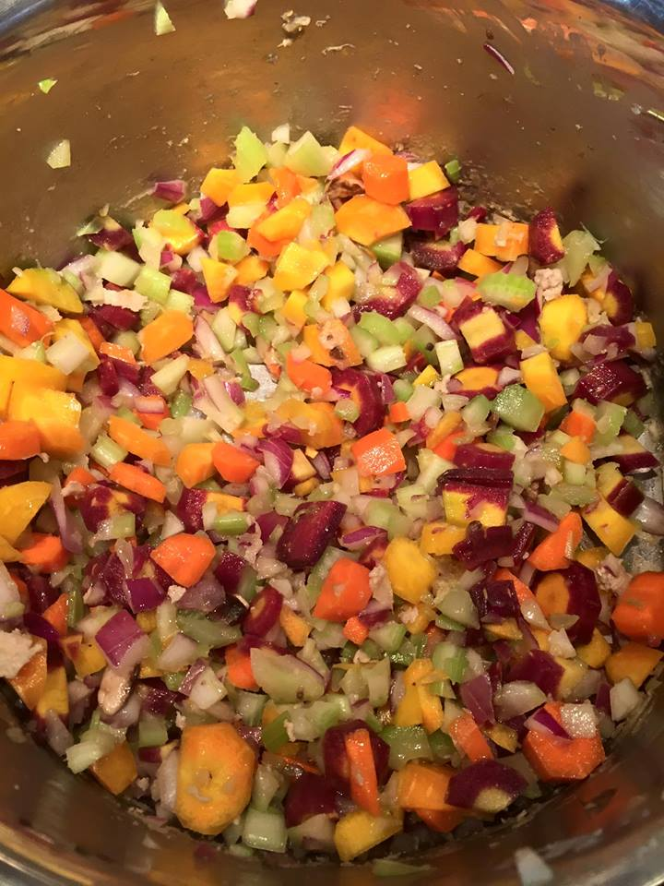
The Base-
It’s all about the base baby!

An excellent start to numerous dishes you can cook and modify from here. Start with the basics and the sky is the limit. Grab your favorite veggies, chop and sauté and this all becomes the base to build upon.
- 4 carrots, washed, peeled and chopped
- 4 celery stalks and leaves, washed and chopped-orange, purple or yellow carrots
- 1/2 onion chopped finely
- 2 cloves of garlic, minced finely
- pinch pink Himalayan salt

Sauté this combo (or make up your own) in olive oil until soft, about 8 minutes. Add some red wine (1/4 cup) and a big squirt of Dijon mustard and you are on your way to having a delicious meal. You can add pasta or meat or beans too as long as you add veggie or chicken broth then simmer it all until cooked thru.

www.loveyourhealthandwellness.com

