Infused Water
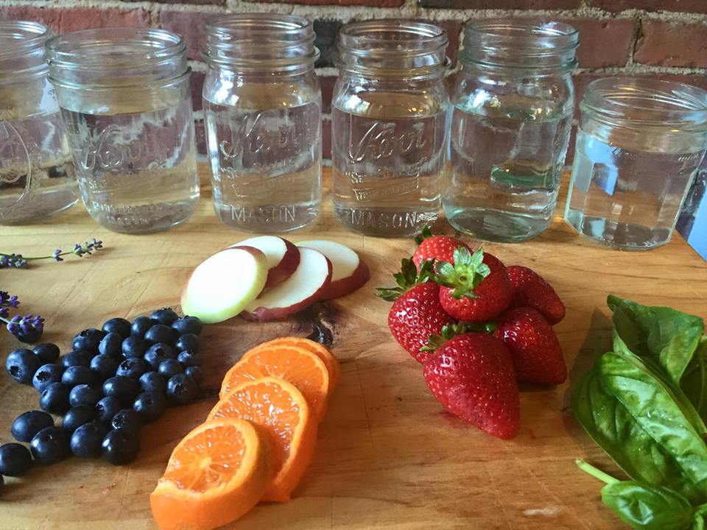
WATER!! You need ALOT of water everyday. How much? Take your body weight and divide that number in half. Remember that number. It is how many OUNCES of water you need a day.
Take a cute glass and fill with water. Add whatever fruit, veg or herb you like then refrigerate for 2-12 hours. Drink them all before the herbs overpower the water and make it bitter. So refreshing!! Try watermelon, grapefruit, pomegranate, rosemary, pear, pineapple, cherry, kiwi, Ginger...

1) blueberries and fresh lavender
2) apples, strawberries and basil
3) oranges and blueberries and basil
4) blackberries, mint and lemon
5) strawberries and lemon
6) cucumber, mint and lime
7) apples and cinnamon sticks
8) apples, ginger root and lemon
9) watermelon and basil or mint
10) cilantro, lime pineapple

Want more tips?? Check out www.loveyourhealthandwellness.com

