Homemade Laundry Powdered Detergent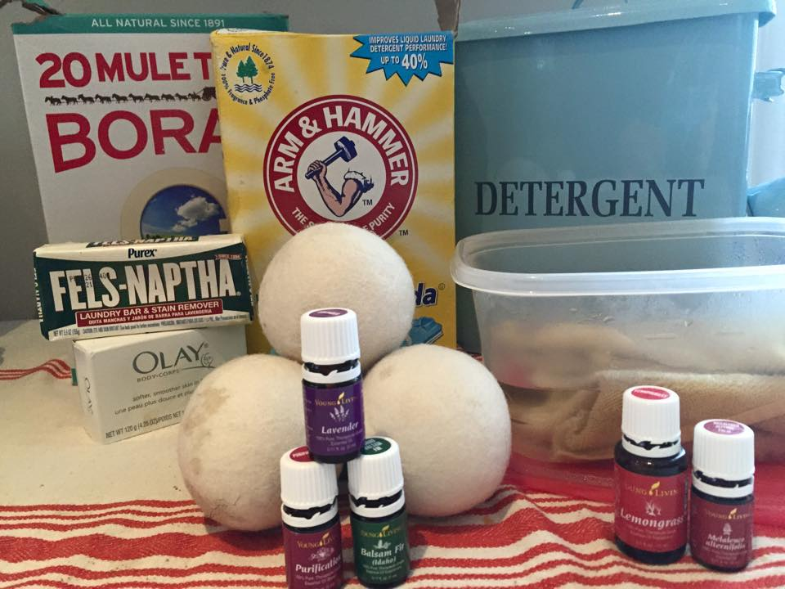

detergent-
Ratio of 1 cup borax to 1 cup Arm and Hammer washing soda to one bar of laundry soap like Fells Naptha, Dr. Bronners castile soap or dove sensitive. I prefere castile in my washer since it seems to completely dissolve versus the Fells Naptha that does not. Grind the bars of soap into the powders then add 10 drops of your favorite EO fragrance. Stir and put in a pretty container. Economical AND Earth friendly!

If you want to mix up a whole batch for a few months:
use the entire box of borax (76 oz), the entire box of super washing soda (55 oz) plus 2 cups of regular baking soda and grate 3 bars of Dr. Bronner's castile soap. Then I add 40 drops of essential oil (I use Young Living’s purification). Stir and add to a pretty container.

Dryer sheets-
Fill a plastic container with water and add a healthy splash of vinegar. Add 8 drops of your fav EO. Add cut up rags (I used an old, clean towel). Keep covered until time to add a wet rag to each wet dryer load. It will make your laundry smell heavenly and won't leave that gross film that dryer sheets do. Alternately, add a few drops EO to wool dryer balls! Fluffs up AND smells amaZING!

