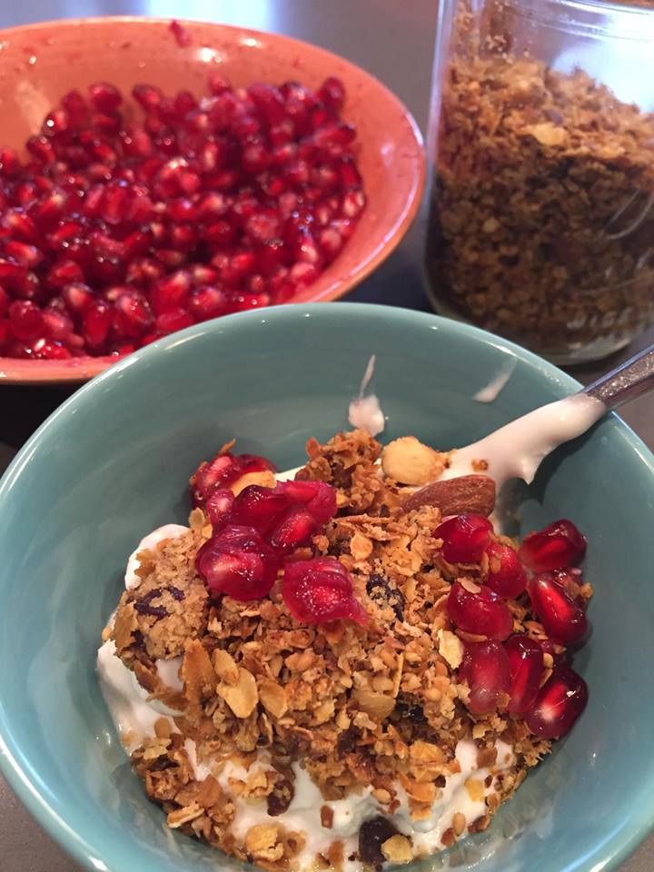
Yogurt Parfait with fresh pomegranate seeds

Add a cup of yogurt of your choice and top with homemade granola and pom seeds. Instant smiles!
Granola recipe modified from The Kind Diet by Alicia Silverstone

Ingredients:
- 6 cups quick cooking oats
- 1/2 cup maple sugar or brown sugar
- 3/4 wheat germ or oat bran
- 1/2 cup shredded coconut
- 1/2 cup salted sunflower seeds
- 1 cup golden raisins
- 1/2 cup canola oil
- 1/3 cup real maple syrup (local if possible)
- 1 1/2 tsp vanilla
Spread the oats on a sheet pan and bake for 10 minutes in a 350 degree oven. While that is cooking, mix all the other ingredients in a large bowl. Remove the oats from the oven and let cool slightly. Dump the oats into the goey mix and stir all together. Spread the mixture evenly divided between two sheet pans and bake for 10 minutes. Stir the mix about ½ way thru the cooking process. Let the granola cool then store in an airtight container. Super cute to pop into a mason jar and add a jute tie or chalkboard label. Everyone loves a homemade gift!

www.loveyourhealthandwellness.com

